EXAMPLE INFORMATION FOR PLANNERS CREATING AND MAINTAINING PRIMAVERA SCHEDULES

By John Verth

GENERAL

Duration Type – Fixed Units/Time for all activities (where resource availability is the most critical aspect of the project.)

% Complete Type – Units % Complete for all Engineering and all Workshop activities. (The Duration % Complete is calculated automatically from the original and remaining duration.) Duration % Complete for all other activities.

Activity types are chosen as required for a particular activity. Engineering and Workshop activities should be ‘Resource Dependent’. Procurement activities should be ‘Task Dependent’.

Tracking – Units % Complete (Permits tracking at the WBS level.)

Project Management and the Web Application use ‘Original Duration’ and ‘Planned Duration’ to mean the same thing. {Note: The Web Application sometimes shows Planned and sometimes shows Original as the title of the same column.}

The ‘Data Date’ is set to show the next available work period. Applying Actuals progresses all activities up to the Data Date. Scheduling moves unstarted activities to start on the data date and also moves any remaining work of started activities to resume on the Data Date.

Rules for Applying Actuals (from Primavera Knowledge Base) (Note that this is an automatic function.):
  - Apply an Actual Start to all activities that have a Planned Start < Data Date. The Actual Start is set to the Planned Start.
  - Planned Finish is not changed.
  - Calculates Remaining Duration as the Early Finish-New Data Date.
  - Calculates Actual Duration as Original Duration-Remaining Duration.
  - Calculates Actual Units as Unit Percent % * At Complete Units
  - If Actual Finish is < Data Date, then an Actual Finish will be applied. The Actual Finish is set to the Planned Finish.
  - Actuals are subtracted from At complete values to calculate Remaining values.
Summary data is set at weekly level in order to provide a reasonable breakdown of resource requirements (Monthly would be too coarse). (This is set using PM Admin Preferences, Options, Specify the interval to summarize and store resource spreads, set WBS Level and Resource/Role Assignment Level to ‘Week’).

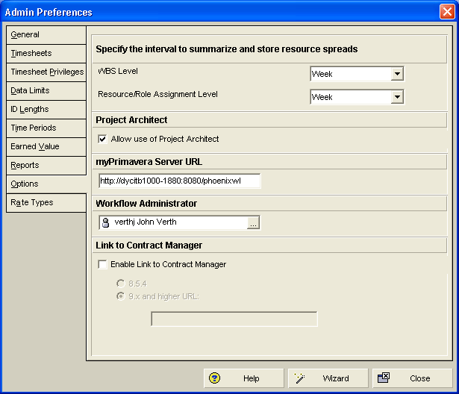

Note that if ‘Summarize’ is not run:

- The schedule dates in the PM ‘Projects’ view may be incorrect.
- Some information in the Web Application may be incorrect e.g. Resource Loading.

Because we are tracking using Duration % Complete, we do not need to include WBS Summary activities. Duration % Complete is rolled up to the WBS structure itself.

In the web application, there is a duration call ‘Total Duration’. This is not included in PM. It is defined as Actual Duration plus Remaining Duration. Total Duration is not the same as Original Duration. Actual Duration is from Start Date to the Data Date so Actual Duration depends on the data date. Total Duration may be different from Original Duration.

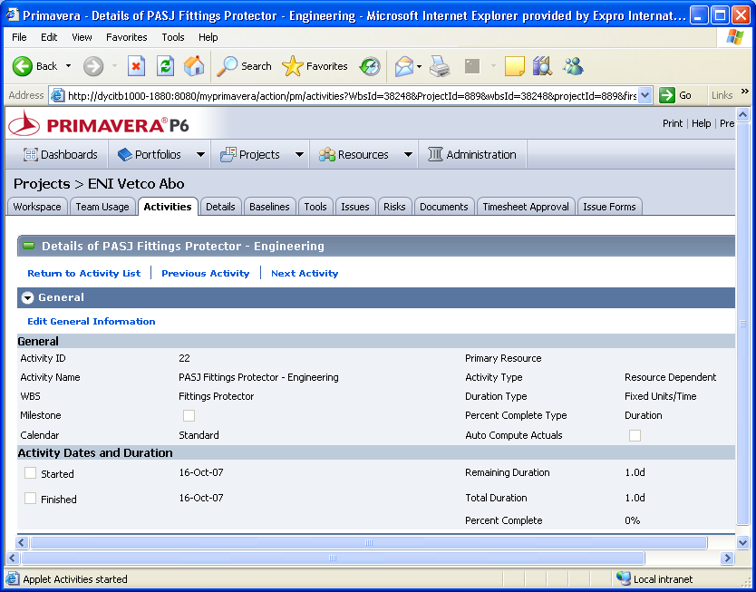

BACKUP COPIES OF SCHEDULES

It is essential to export copies of project schedules in order to have backups readily available. For each active project, an export of the schedule should be performed daily with the backup copy being saved into the project Planning/ Backups folder. The name of the exported copy must be unique and should include the date saved.

USERS

Users should be created on the system using the same login name as their windows login. A resource should be created in the appropriate Resource location and allocated to the user. The contact e-mail and telephone contact details should be added. The minimum global access should be allocated and appropriate resource access allocated if necessary. User interface views are not currently utilised. Project access should be allocated as appropriate with the minimum security profile required. The appropriate licence(s) must be allocated.

An additional Security Profile has been created (PM, Admin, Security Profiles) called ‘Project Team Member’. This profile is limited to the single privilege ‘Add/Edit Project Activities Except Relationships’. This profile should be allocated to engineering design managers, project coordinators, and assembly manager etc. to limit them to activity updates only. These users have Team Member licences and can still see all of the project’s WBS but can only see and update the activities allocated to them. A Team member must be either a Resource allocated to an activity in order to see the activity or they must be the Owner of the activity.

Each project WBS is constructed to restrict write access to the appropriate section of the schedule. For example, by using the OBS, engineering design managers are allocated to the Engineering WBS, project coordinators to Procurement WBS and the assembly managers to the Workshop WBS.

CREATING PROJECT SCHEDULES

Projects should be created using the Project Architect and utilising the templates in Methodology Manager. Using the Bill of Materials (BOM) as a guide, all of the items on the BOM should be included in the project schedule. A new project is created in the appropriate section of the EPS. The base methodology is ‘Base’ and the assemblies and items contained in the Bill of Materials can be added as plug-in methodologies. Engineering Sale or Rental sections can be removed as necessary. Once the project schedule has been created, WBS sections can be copied if there is more than one assembly in the scope of supply. Elements of the WBS will have to be rearranged in order to locate them in the appropriate Engineering, Procurement or Workshop section.

In order to introduce a stagger in starting engineering activities, a lag from the project kick off milestone to engineering activities should be added. The lag should be adjusted to provide a Total Float of between 20-25 days.

PROCUREMENT

Procurement updates are expected to take place on a daily basis. All procurement activities are tracking using Auto Compute Actuals but this is applied to Procurement activities only when the relevant requisition request is raised.
The Apply Actuals Job Service is run every night.
Apply Actuals can be run at any time by the planners.

When a Requisition Request is raised, the Project Coordinator carries out the following actions using the Web Application with the Material Tracking view.

Note: It is important to carry out these activities in the order stated.

- Select the appropriate activity.
- Change ‘Planned Start’ date if necessary to show the date that the Requisition Request was raised.
- Change ‘Activity Status’ from ‘Not Started’ to ‘In Progress’.
- Tick ‘Auto Compute Actuals’.
- Save changes by using the Save icon .
- Ensure that the edit icon () disappears.

When the PO for the item has been placed:

Note: It is important to carry out these activities in the order stated.

- Select the appropriate activity.
- Change ‘Order Status’ to ‘Confirmed Delivery Date’.
- Change ‘Finish’ to read the same as the vendor Last Promised Date.
- Save changes by using the Save icon .
- Ensure that the edit icon () disappears.
- Change ‘Original (Planned) Duration’ to read the same as ‘At Completion ‘Duration’. (This ensures that the correct duration, which has been placed on the PO with the vendor, is recorded.)
- Save changes by using the Save icon .
- Ensure that the edit icon () disappears.

When an item is delivered:

Note: It is important to carry out these activities in the order stated.

- Change the ‘Finish’ date to reflect the actual delivery date.
- Change ‘Order Status’ to ‘Completed’.
- Untick ‘Auto Complete Actuals’.
- Save changes by using the Save icon .
- Ensure that the edit icon () disappears.

Note that Start and Finish dates can also be updated on the Gantt chart by selecting the activity and then dragging the appropriate end of the bar to the new date.

All vendors are listed under a ‘Contractor Code’ found at Enterprise, Activity Codes, Contractor Code.

Major forgings are coded ‘MF’ under the Activity Code ‘Manufacturing Code’.

PROGRESS TRACKING

Progress Spotlight can be used to highlight the activities for the previous week required to be updated to the new Data Date.

All progress tracking will use Duration % Complete which is computed as ((Planned Duration - Remain Duration) / Planned Duration) * 100. It is always in the range 0 to 100. The planned duration is the same as the original duration in the current plan. For procurement activities, Planned Duration may have to be altered when the vendor promised date is received in order to reflect the vendor’s expected delivery time.

LEVELLING

Backward levelling can be carried out if ‘Preserve scheduled early and late dates’ is cleared. (Tools, Level Resources)

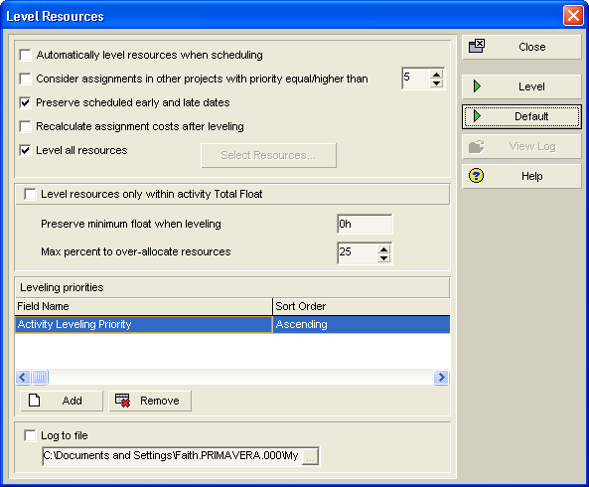

PROJECT WEB SITE

A project web site is created for each project and is located in a sub folder in the Planning folder. The web site should be republished at the end of each working day. It is planned to run this as a job service when this facility is included as an enhancement by Primavera.

An HTML copy of the schedule can be published (File, Print Preview, Publish to HTML) which is quicker than publishing the web site. It is also quicker to publish the HTML copy to a local drive first and then copy it to the project folder.

JOB SERVICES

As updates are applied to the schedules on a daily basis, Job Services are run every night at 0100. Job Services are run in the following order:

- Apply Actuals
- Schedule
- Summarize
- Export

Notes:
  - The Data Date must be updated manually prior to the Job Services running. (Automatic incrementing of the Data Date is subject to an Enhancement Request.)
  - New projects must be added to the job service as required.
  - The Export function copies all projects to a backup file but it overwrites the previous version.

PROCUREMENT COSTS

Procurement costs are tracked under ‘Project Expenses’. AFE and Sub-AFE information is created in ‘Cost Accounts’. In ‘Project Expenses’, the ‘Budgeted Cost’ is used to represent the expected cost provided by SAP. In order to ensure that the ‘Estimate at Completion’ is correct, ‘Remaining Cost’ must be set initially to the same value as ‘Budgeted Cost’. When ‘Actual Cost’ is recorded, the value of ‘Remaining Cost’ must also be updated.

ROLE AND RESOURCE COSTS

Role and Resource costs are entered in /hour or /day and set in Admin Preferences, Rate Types. Actual values are entered in Enterprise, Roles or Enterprise, Resources.

Role and Resource costs are allocated to Cost Accounts in the Resource Assignments view. For resource costs to be calculated automatically from resource units, ‘Cost Units Linked’ must be selected. (Resource Assignments, group by resource, insert ‘Cost units Linked’ column, select tick box, fill down)

EARNED VALUE CALCULATION

In order to ensure that the baseline reflects the correct dates, we need to select current dates rather than planned dates. Choose: Admin, Admin Preferences, Earned Value Calculation, Budgeted Values with Current Dates.

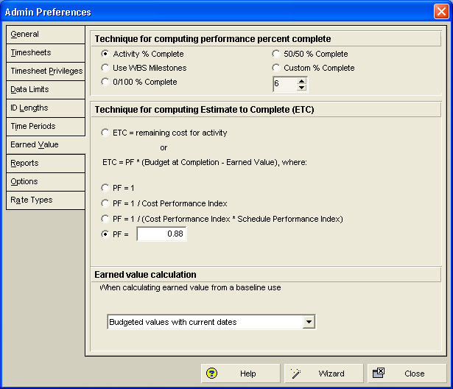

For all procurement activities, the ‘Technique for computing Estimate to Complete (ETC)’ should be set to ‘ETC = remaining cost for activity’. This ensures that the correct ‘Estimate at Completion Cost’ is calculated. To apply this setting, select WBS, select the Procurement WBS, select the Earned Value tab and choose ‘ETC = remaining cost for activity’

BASELINES

For all projects, in order to track progress correctly, a baseline must be created and allocated to the project. The baseline should be created when all of the project information has been obtained and the project is ready to kick off. There must be no progress on the schedule before the baseline is created. This initial baseline must also be agreed with the client. The baseline is created by selecting Project on the toolbar, Maintain Baselines, Add, Save a copy of the current project as a new baseline. This baseline is then allocated to the project by selecting Project on the toolbar, Assign Baselines, and allocating the baseline to the Project Baseline and to the Primary User Baseline. The Project Baseline ensures that for consistency the same baseline is used by all users. User Baselines may be created by individuals for their own purposes.

Use the ‘Save a copy of the current project as a new baseline’ option

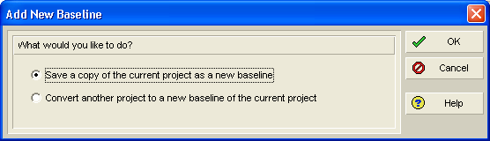

and then assign the baseline to the project (Project, Assign Baselines).

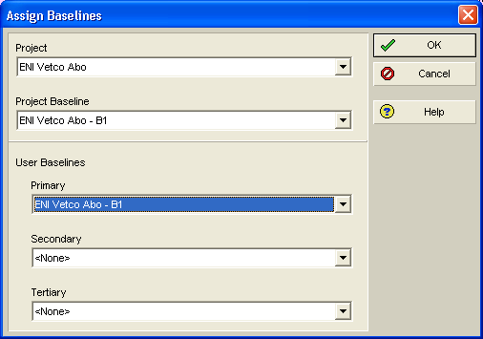

For imported MS Project files, a baseline has to be created. Ensure that the Earned Value Calculation is set as described above. Create a baseline (Project, Maintain Baselines, Add)

Ensure that this initial baseline is then assigned to both the Project Baseline and the Primary User Baseline.

ENGINEERING AND WORKSHOP UPDATES

It is possible that Engineering and Workshop updates may be provided on a daily basis. For both Engineering and Workshop activities, progress updates will be supplied as ‘Remaining Duration’ using the web application with the Global Default view. The update procedure is as follows:

- Select the appropriate activity.
- When activity commences, change ‘Activity Status’ to ‘In Progress’.
- Update the ‘Remaining Duration’ field.
- Save changes by using the Save icon .
- Ensure that the edit icon () disappears.
- When activity is complete, change ‘Activity Status’ to ‘Completed’.
- Save changes by using the Save icon .
- Ensure that the edit icon () disappears.

Note that when Remaining Duration is updated, the At Completion Duration and the Gantt Chart may not show the correct information until Apply Actuals is applied.

Note that Start and Finish dates can also be updated on the Gantt chart by selecting the activity and then dragging the appropriate end of the bar to the new date. Progress can also be updated by dragging the progress bar.

WEB APPLICATION

Dashboards In the ‘My Projects’ portlet, the % complete variable used is Duration % Complete.

Portfolios. In Executive Summary with Performance and Earned Value measured using Cost information (as selected in Preferences) the % complete variable used is Performance % Complete.

MS PROJECT IMPORTS

Projects imported from MS Project may inherit a Project ‘Must Finish By’ date. This can cause problems if activity durations subsequently become shorter as no items would have zero Total Float and no critical path would be apparent. This ‘Must Finish By’ date should be cleared in the Projects View, Project Details, Dates by clearing the contents of the ‘Must Finish By’ box.

The following Custom Field Mappings are used in the template when importing MS Project files:

Subject | MS Project Field | Primavera Field
Project Phase | Text 4 | user_text4
Assembly Code | Text 6 | user_text6
Part No | Text 7 | Part Number
CPO No | Text 10 | CPO Number
Qty | Text 13 | Quantity
Item No | Text 17 | Item Number

WORKSHOP DELIVERY PLAN

The Workshop Delivery Plan is included in the Future Projects schedule. The major assemblies are included for each potential future project. An ‘Action Code’ of ‘WDP’ is used for each line to be displayed in the Workshop Delivery Plan. Each line also has the appropriate ‘ Assembly Code’ and ‘Working Team’ allocated to it. Gantt chart bars are colour coded according to the assembly type. The appropriate view can be obtained by utilising the ‘Workshop Delivery Plan’ layout. This layout uses the following settings:

- Grouping using ‘Working Team’, selecting the ‘Group By Options’ of ‘Hide if empty’ and ‘Show: Name / Description’.
- Applying the filter for ‘Workshop Delivery Plan’.
- Sorting by ‘Start’.

For managers, the simplified ‘Workshop Delivery Plan – Print View’ layout should be used.

FINANCIAL PERIODS

Tip from Help: To enable P6 Web Access users to display financial period timescale intervals in charts and spreadsheets, you should create a batch of financial periods that contain no time gaps and have a minimum duration of one week (seven days). If any time gap exists between two financial periods, or if any financial period spans less than seven days, the Financial Period timescale cannot be displayed in P6 Web Access.

METHODOLOGY MANAGER

Use the ‘Base’ Methodology with plug-ins.

The first activity in each procurement section or sub section is categorised with the Project Phase code ‘proc’ to allow for filtering and sorting. The remainder of the activities are coded ‘man’.

FUNCTIONALITY MATRIX

There is a P6 functionality matrix, comparing the facilities available (or not available!) in PM and Web Access, located in the POINT system at prim56254.

NOTES

Consider using Reflection projects for an additional level of security where users update the Reflection copy of the master schedule. The project planner then reviews the changes and merges the required changes into the master schedule. (Note (From primavera Help): Merging will not necessarily remove items from the source project that have been deleted from the reflection. If major elements of a project have been deleted from the reflection, you will have to manually delete them from the source project if you do not want to keep the elements in the source project. Elements that are not deleted during a merge include Activities, Resource Assignments, WBS elements, Work Products and Documents, Project Expenses, Project Issues, and Project Risks.)

EXTRACTS FROM PRIMAVERA HELP

Update progress for individual activities
- Choose Project, Activities, then select the activity you want to update.
- Display Activity Details, then click the Status tab.
To update actual dates, mark the Started checkbox, then specify the actual start date in the Started field. If the activity is complete, mark the Finished checkbox, then specify the actual finish date in the Finished field.
-Or-
To update activities with Duration percent complete type, click the Remaining field and type the remaining number of workperiods needed to complete the selected activity. When you schedule or apply actuals, the actual duration is calculated as the total working time from the actual start date to the current data date (for in-progress activities) or to the actual finish date (for completed activities), using the activity’s calendar.
-Or-
To update activities with Physical percent complete type, type the physical percent complete and the remaining duration for the activity. If resources are assigned, you must also update each resource’s actual regular units.
- Repeat the previous steps for each activity you want to update.
Tip
- To automatically update actual units and costs when Duration percent complete is updated, you must mark the checkbox to Recalculate Actual Units and Cost when Duration % Complete Changes in the Calculations tab of Project Details.
- If you manually plan future period resource/role distribution in the Resource Usage Spreadsheet, the module updates progress for individual activities based on the manual values you enter for assignments. How?
If you update activity progress by modifying Duration % Complete or Remaining Duration on the activity, the activity's actual units are updated using the manual remaining unit distribution when you apply actuals, as long as the project option 'Recalculate Actual Units and Cost when duration percent complete changes' (Project Details, Calculations tab) is marked.
If you update activity progress by modifying the Remaining Units or Remaining Early Finish on the assignment, the activity's actual units are updated using the manual budgeted unit distribution when you apply actuals, as long as the project option 'Recalculate Actual Units and Cost when duration percent complete changes' (Project Details, Calculations tab) is marked.
If you update activity progress by modifying the Actual Units on the activity or assignment, manual future period budgeted and remaining unit values are not updated when you apply actuals.

Footnotes:

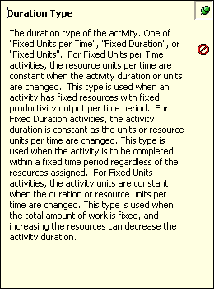 From Web application Help: More about choosing a default Duration Type Based on an activity's duration type, resource data is calculated by synchronizing duration, units, and resource units/time so that the following equation is always balanced Remaining Units (resource) = Units/Time X Remaining Duration (activity) For example, if a resource is assigned to an activity 8 hours/day for 5 days, the remaining units, or work effort, is calculated as 40 hours. The duration type controls how the equation is calculated when you change one of the values. When schedule is a limiting factor in the project, choose either Fixed Duration and Units/Time or Fixed Duration and Units. In this case, the activity's duration is fixed regardless of the number of resources assigned when you modify or update the activity. Typically, you choose this duration type for a task dependent activity that requires a set amount of time to complete, regardless of the number of people working on it. You can choose to have the remaining units or units/time calculated when you update the activity. To recalculate the remaining units and keep units/time for the resource constant, choose Fixed Duration and Units/Time Remaining Units = Units/Time X Remaining Duration To keep the remaining units constant and recalculate units/time, choose Fixed Duration and Units Units/Time = Remaining Units/Remaining Duration When resource availability is the most critical aspect of your project, choose Fixed Units/Time. In this case, the units/time or rate of the resource remains constant, even if the activity’s duration or total work effort changes. You most often use this duration type when planning resource dependent activities; for example, you have a programming consultant who can only work 4 hours/day. When budget (units or cost) is a limiting factor; that is, the total amount of work is fixed, choose Fixed Units. When you update activities, the work effort required to complete the activity does not change, even if the activity’s duration or the resource rate changes. Typically, you would use this type in conjunction with resource dependent activities. Increasing resources can decrease the activity duration. For example, if a department needs to install equipment for 100 employees, you have a fixed amount of work, but adding resources to complete the installations simultaneously could reduce the time it takes.
